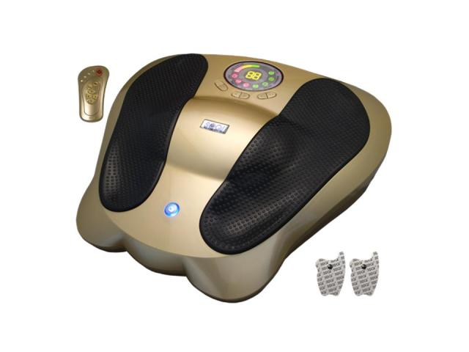  The Adv. ERE is not just a foot massager; it is effective at producing the ultimate feeling of relaxation, while balancing the body.  This product also provides the option of using (3) sets of electro pads which can be used simultaneously with the foot massager.  Note: Extra BVPs are not commissionable. Extra BVPs points accumulate in your account for your next promotion. | Item Code: P0019M01  Advanced Electro Reflex Energizer  USD $ 419.00  BVP 37  Extra Promotion Point(s) 8

