For Sale Filly
Joni’s Star Dancer
Paso PFHA# - 50,586
Born: June 13, 2006

Website www.jonilund.com

Marichal Bolero LaCe by Volare/ Morena
Bandolero Royal_ # 68922 Black Sofia La Negra by Dulce Suneo/ Sofia Alazana
# 1,327 Black, Endora Nino by ? Dulce Sueno
Pegasus Estaban____ # 68971 Black, Col Sierva ?
PFHA # 8,802 Pino Don Miguel Estaban Boricua by Batalla/ Nevada Cosa Differente Estaban # 69849 Roan Ilusion Godreau by Guamani by Dulce Sueno
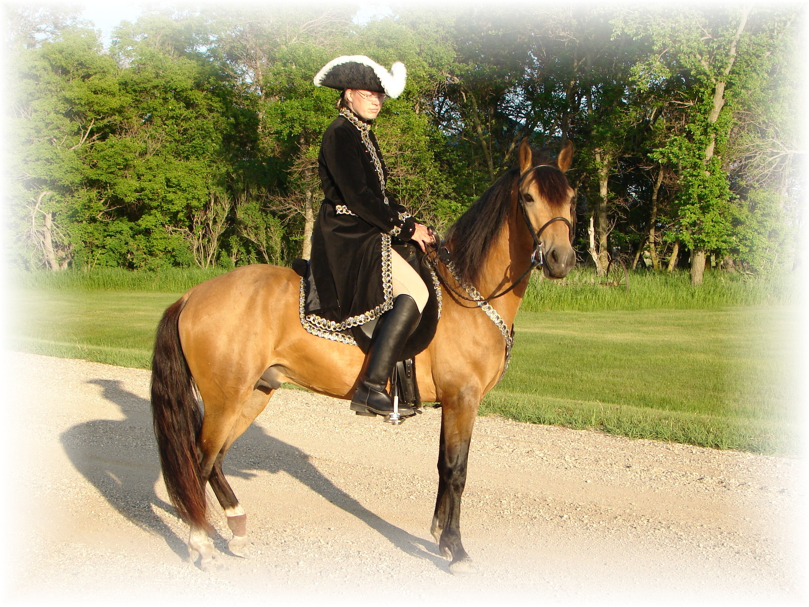
# 1,922; #70744 Pinto Fudia Estaban Danza by Guayama/ Espada
Monteado dePegasusPisadas # 70741 Bay pinto Rosita by Magia Blanca/ Princesa
# 23,618; #91529 Red/Bay tobiano Bolero LaCE Volare by Pincel/Princesa Mora
Campesino La CE # 68824 balck Morena by Gringo/Marianela # 1988 #70810 Bay; PR Dalfia LaCE Muneco LaCE by Lucifer/ La Polvora
Norelle de Encato #68870 gray Dalia LaCe by Gaucho/ La Dalia
#9359 #78181 Bay unknown unknown
Gitana Rosa unknown
SIRE # 2998 #71820 pinto unknown unknown
Future of Pisadas de Oro unknown
PFHA# 44,422 Sonador Ese Si by Guamani / Negra
- APLHA# 8603 Sizcocho LaCE #102096 PR#310 Enriqueta by Copa/ Dona Yin
- #HOA 1489 #512 #69334 Bay Maravilla LaCE Guamani by Dulce Sueno/Cordondillo Alazana
#NAM 05650 Tesoro Salago 102124 La Doctora by Dulce Sueno/Cordondillo Alazana
Buckskin #519 #69341 Sombre LaCe Cori by Marinero/ Santa Elena
Buckskin (PR) Lunina LaCE #102152 Palomino Maria Luisa by El Huerlano/ La Crema
Alegria Salago #507 #69329, PR Carina LaCE Rojo by unknown
- #10133 #78955 ¾ PR/ ¼ col #68887 Vieja by unknown sire/ dam
Buckskin Very intelligent Muneco LaCE Lucifer El Cacque by unknown sire / dam
- #3 #68825 Gray #102031 (Col.) La Melva by unknown sire / dam Gwenona LaCE La Polvora Resorte I by Jupiter
- #517 #69339 #102032 (Col.) La Ninfa by unknown sire/ dam Bay? Brown Monona LaCE Furioso (aka Fury) Noche Buena by Dulce Sueno/Estrella
- ½ PR/ ½ col #510 #69332 #102075 (PR) Violeta by Dulce Sueno/ Felipa Bay PurePR Cocoa II Altanero by Caramelo#102033/ ? #102798 Cocoa by Unknown sire/ dam
Capuchino Resorte Quarto Resorte III Representante Capuchino #75766 Capuchina III Resorte Quarto/Capuchina III
# 86071 Dona Rita Lord Corzo/ Soraya
Motivo # 76428 Sirena Mensajero/Balanlaika
# 86612 Criol que tal Mahoma Triunfo/ Mecita de Salgar
Gala que tal # 68988 Salpicada Campoalegre/ Cocoa Cola
# 69001 Guala Plumaje Piel Roja/ La Venus
Acero de Plata NPF # 68969 Celosa Gaucho/ La Oka
# 92698 Muneco LaCE Lucifer El Cacque/ La Melva
Caliente LaCE # 68825 La Polvora Resorte I/ La Ninfa
# 69721 Mirabel LaCE Sondar Ese Si/ Enriqueta
Caliope # 70223 Piel Canela Guamani/ Piel de Seda
# 74645 Corinto Conde Presidente/ Haydee
Cristina # 102208 Sorpresa Guamani/ Color Rosa
DAM # 71940 Siba Caramelito Caramelo/ Canaria
Joni’s Westford Dakota #69413 Casimba Cacique/ Old One
PFHA # 34,190; # 111976 Mahoma Triunfo Andino/ La Chispa
Bay turned Gray 13.1hh to 13.2hh Choco que tal #102310 Mecita de Salgar ?
# 68992 Fino Fino Campesina ?
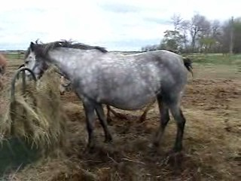
# 102310 ?
Chocante Cabal Hilachas Zipa ?
# 75468 Escusha que tal # 68972 Muneca de VI ?
#68992 Cucuracha Estrellas ?
Velvet Mi Lu # 102306 Companera ?
# 82015 Guamani Dulce Sueno Caramelo/ Mosqueda
Faeton LaCE #102050 CordoncilloAlazana Patiblanco/ Cordoncillo Zaina
#68877 Piel de Seda Piel de Seda ?
Companita LaCE # 102107 La Godreau Pocholo/ Rubia
# 68962 Volare Pincel Copita (Don Q)/ Santa Rita II
Volacia LaCE # 102025 Princesa Mora Pisaflores/ La Rucia
# 69753 Veronica LaCE Dulce Sueno II Dulce Sueno/ Princesa
# 102402 Buena Copita/ Nina
Joni Lund – Equine Services & Trading Post, 1295 1st ST S, Carrington, ND 58421
(701) 652-1986
Semen Collection & Shipping Service - Horses - Mules - Tack

Bloodlines of : Future of Pisadas de Oro

Monteado dePegasusPisadas: Sire 14.3 hh; 15 mph. Nice long, smooth Largo and an easy, rocking canter. Great Western pleasure type Paso. Beautiful tri-colored Red/bay Pinto. By Pegasus Estaban X Norell de Encanto.
Alegria Salago: Dam 14.2 hh; 16-17 mph evenly gaited. Very intelligent. Of Tesoro Salago X Gwenona LaCE.
Pegasus Estaban was unbeatable in the show circuit in pleasure class. Took third in National, when a hoof trimming left him very tender. Three time reserve national champion. Style & presence.

Bandolero Royal Grand National Performance Champion, Great Largo. Grand National Pleasure champion.
Sizcocho LaCE: Sired by Puerto Rican island champion Esi-si by Guamani. Sizcocho‘s dam, is direct daughter of Guamani . ( Guamani & Batalla direct sons of Dulce Sueno).
Tesoro Salago buckskin, big, tall, showy, & fast.
Gwenona LaCE Brown 5.17/1971
Dulce Sueno on pedigree 44 times, renowned. Archetype of the Paso Fino breed. Dulce Sueno is considered one of the most significant stallions in the history of the breed from the island of Puerto Rico.. Pure Puerto Rican. Largo. PR0261, Dk. Bay. Golden eyes.

Sombre LaCE: Never shown out of region. But contributed heavily to the breeding programs in local region. Beautiful golden, dappled Palomino.

Batalla: Son of Dulce Sueno. Fast. Largo. Dk. Bay, two socks. PR0032, 8/4/1935.

Nevada #102880 14hh Champion

Gaucho:

Muneco LaCE #68825 Two time Grand National Fino Champion. Gray PFHA#3

Resorte I Famous bloodlines.

Guamani : by Batalla by Dulce Sueno by Carmello by Faron II by Faron (an Andalusian). Guamani: 4 Time Puerto Rican Island Champion.

Marichal: Grand National Confirmation Champion, by Bolero LaCE a black foundation sire.

Muneco Two-time Grand National Fino champion. mare
Don Migeul Estaban: Black by Borquel, son of Batalla.

Sombra: Three sons, all Top 10 sires.

Bolero LaCE: a black foundation sire, champion.

Ese Si: Porto Rican island champion.

Resorte I: Island Champion
Bloodlines of : Joni’s Westford Dakota

Dulce Sueno: ,Listed on Dakotas Pedigree 29 times that we could find. Dulce Sueno is renowned. Archetype of the Paso Fino breed. Dulce Sueno is considered one of the most significant stallions in the history of the breed from the island of Puerto Rico.. Pure Puerto Rican. Largo. PR0261, Dk. Bay. Amber eyes. That is 73 times between Sire and Dam for Star.

Mahoma:

Batalla:

Muneco LaCE

Capuchino:

Hilachas:

Faeton LaCE: was foaled in Puerto Rico in 1956. His sire was the famous four-time Island Champion, Guamani. His grandsire was the legendary Dulce Sueno. The name Faeton is the Spaish version of the Greek God Faethon. Like his grandsire Dulce Sueno, Faeton’s eyes were a golden color, not the dark brown found in most horses. He was a bright chestnut with four socks and a blaze.

Sire’s side: Guamani by Batalla by Dulce Sueno by Carmello by Faron II by Faron (an Andalusian).
Faeton’s dam: was Piel de Seda, whom had a strong strain of Andalusian blood. There were few other paso Fino’s in the US at the time Faeton was imported from Puerto Rico that were as closely related to Dulce Sueno.
IN 1971, he was the American Paso Fino Horse Association Sire of the year. Sire of the Year in 1973. Faeton is the sire of Poseidon, Island Champion in 1956-66. He was a half brother to Mr. Puerto Rico, another Island Champion. He was half brother to jacquelin, national Champion Paso Fino mare in Puerto Rico in 1966, 67, & 68.

Piel de Seda:

Princesa Mora:

Caramelo:

