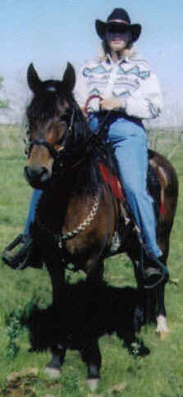
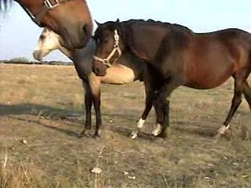
For Sale or Contract for foal.
Esperanza de Irlanda
Bay Mare, Paso Gait
PFHA# 21,564
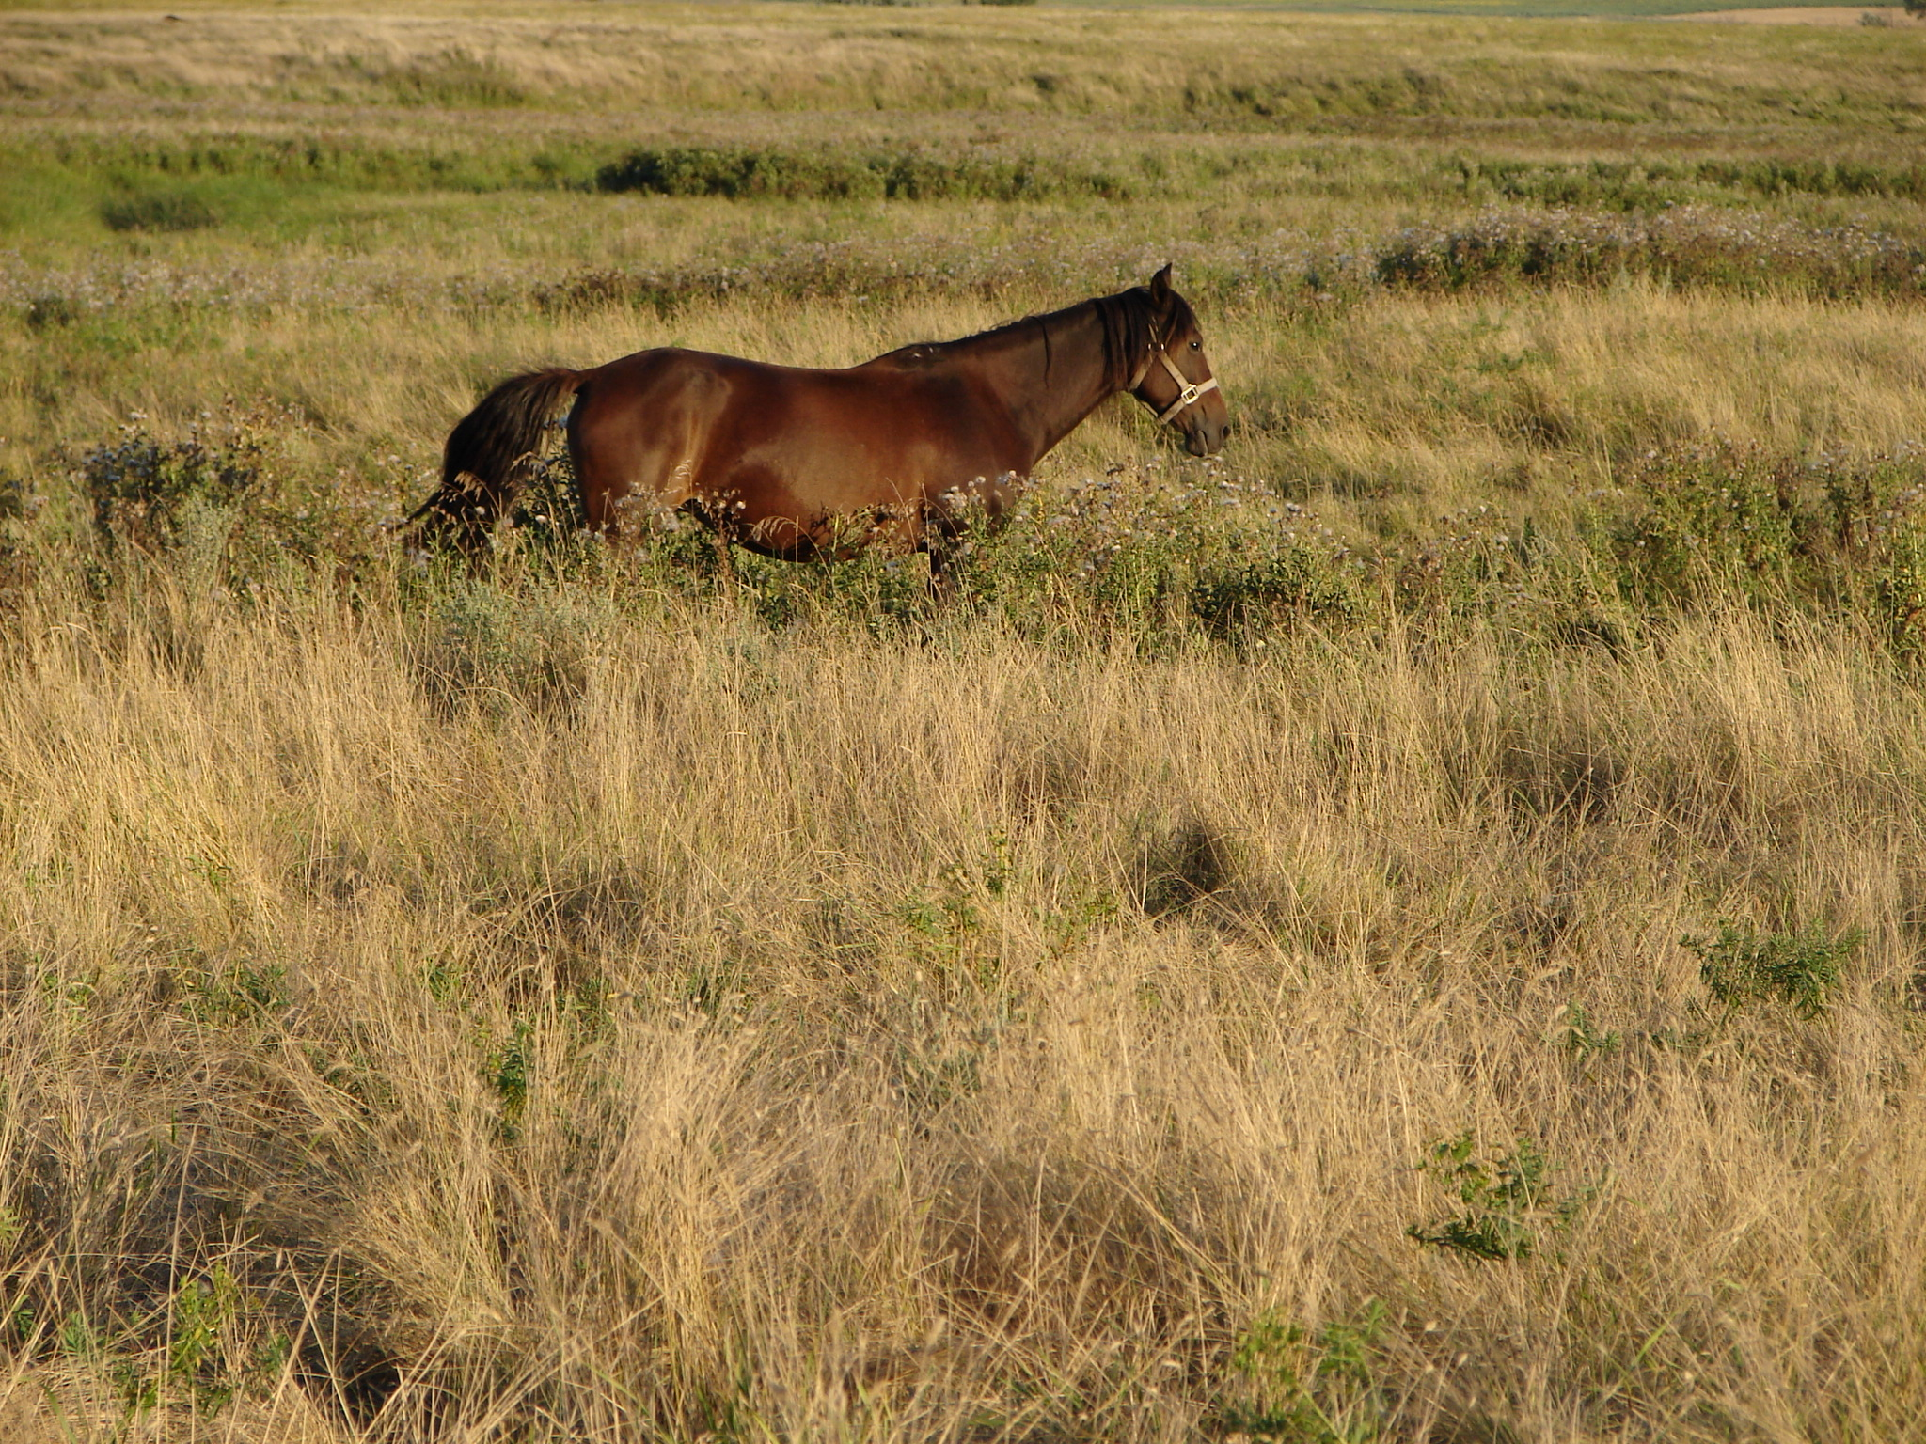
Born: April 22, 1993
13hh

Website www.jonilund.com

Bolero LaCE Volare by Pincel/Princesa Mora
Marichal 68824 Morena by Gringo/Marianela
100 Black Sofia La Negra Dulce Sueno by Caramelo/Mosqueda
Bandolero Royal 102039 Sofia Alazana by Patiblanco/Cordoncillo Zaina
1,327 Black Endora Nino Dulce Sueno by Caramelo/Mosqueda
149 Black 102090 unknown
68971 Sierva unknown
Pegasus Estaban 102408 unknown
8,802 Black Pinto Boricua Batalla by Dulce Sueno/Felipa
Don Miguel Estaban 102881 Neveda by Patiblanco
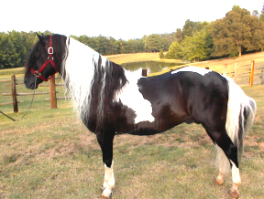
1,027 Roan 69849 Ilusion Godreau Guamani by Dulce Sueno/Cordoncillo Alazana
Cosa Differente Estaban 103164 La Greco by Guamani/ Ilusion
1,922 Buckskin Pinto Danza Guayama by Guamani
Fudia Estaban 103368 Espada by Cacique/Espadita
1,919 Bay Pinto Rosita Magia Blancia by Guayama/ La Loca
70741 103369 Princesa by unknown/unknown

Sire Dablado Sombre Hombre Genty
2,087 Pinto 70836 pinto Fudia Estaban by Danza/Rosita
Estaban’s Diablo 70909 Careta Princesa El Checha
3,928 Black & White 70835 Baya by Sorpresa/Zaina
pinto Don Miguel Estaban Boricua by Batalla/Neveda
Cosa Differente Estaban 69849 Ilusion Godreau by Guamani/La Greco
Conchata Estaban 1,922 Pinto 70744 Fudia Estaban Danza by Guayama/Espada
6,299 Pinto 1,919 70741 Rosita by Magia Blanca/Princesa
Very good pinto largo Baron que tal Eblis unknown
Breeding for 60s & 70’s Favorito Que tal 69127 Maria Bonita by Eblis/Diana
1983 mare Komsashor Athena 1,908 Bay 70730 Sombra unknown unknown
#3,928 Bay Largo 68979 Sanforizada by unknown
50%Col.50%PR Faeton LaCE Guamani by Dulce Sueno/Cordoncillo Alazana
Mininerva de Faeton CJ 68877 PR unknown
1,648 Palomino Mia Suena Canario by Palomo/Calabaza
68878 Redonda by unknown

Joni Lund- Equine Services, Rafter J Bar, 1295 1st ST S
Carrington, ND 58421
(701) 652-1986
Semen collection/shipping Service - Horses - Mules - Tack

A Video is available. See website : www.jonilund.com

