Total Detox is Your Solution!
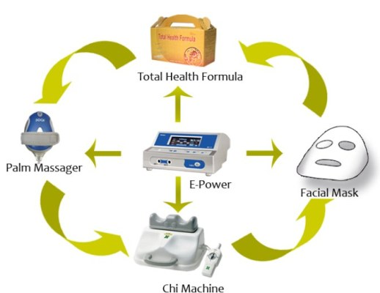
"OPEN UP FIRST, THEN SUPPLY INTO"
Total Detoxification Spa
E-Power, Chi Machine, Total Health Formula, Facial Mask, Palm Massager
We live in a world absorbed with pollution. The 21st Century brings with it stress, environmental toxins, unhealthy diets and fast food. Illnesses like cancer, heart disease, arthritis and other lifestyle diseases are becoming frequent. The vital need to stay healthy and maintain a cleansed body is necessary for the obtaining the best quality of life.
We need to focus on pure body detoxification. The opening up of blocked passage ways for ideal blood circulation is important for ultimate bodily cleansing. We start this treatment by coating the inside of the body with our enzyme packed Total Health Formula. Start this treatment in the morning and take ½ bottle of Total Health Formula. Delude with water or apple juice if preferred.
Next we use E-Power to open up blocked passage ways. The E-Power emphasizes toxin excretion and nutrient absorption. Strap on the e-power belt and apply facial mask to face. We recommend starting the e-power in low mode for about twenty to thirty minutes and working up to higher modes and durations with experience! Please Note that you should remove all metallic items and refrain from using any electrical devices while using this device.
Next, lie down and use the Chi Machine for fifteen minutes while using the Palm Massager on the stomach. The Chi Machine and the Palm Massager assist in further opening up of the body’s blocked channels by the application of internal massage to the organs. Now that we have opened up passage ways and channels we will focus on supplying essential nutrients back into the body with Total Health Formula. Take the other half of the bottle of Total Health Formula with water or apple juice after completing the entire procedure. Repeat this cycle daily for about one week and there you have it!
In conclusion, we have used these devices to expand blood vessels, capillaries and arteries to assist in rapid toxin release and then supplied them with essential nutrients which are then rapidly absorbed into the bloodstream.
Achieve Total Detoxification
with the Total Detox Spa by HTE!
This exclusive combination of products is what you need to rejuvenate your body giving it the cleansing kick it needs from the inside out!

TOTAL DETOX
Introducing the Total Detox Spa! This unique approach to cleansing combines electric energy, motion energy, nutritional supplements and skin care products to release unwanted toxins from the body.

E-Power – Electric Energy
E-Power utilizes what the science refers to as negative potential energy. This magnificent machine is specifically designed to balance the body’s energy levels. When the body is in a state of balance, it thrives! Learn More...

Bianca Facial Mask – Skin Application
The Facial Mask is a specially formulated formula of high quality ingredients that aim to silken and beautify your skin! Notice the difference overnight! Learn More...
Chi Machine – Motion Energy The Chi Machine combines the aerobic movements of swimming and running and naturally oxygenates the body effortlessly while lying in a relaxed position. Learn More

Palm Massager – Full Body Massage
The palm massager provides an invigorating massage capable of full body use. At over 3,000 pulses a minute, target any area of the body where you experience pain for instant relief! Learn More...

Total Health Formula – Nutritional Supplement
Using Total Health Formula is simply a way to get your healthy dose of nutrients and enzymes you need from whole foods in one convenient form. Total Health Formula is made from the freshest, highest quality of 102 different kinds of fruits and vegetables. Learn More

Detox. 7 day Treatment (Suggestion)
Clean / Detoxify / Digest / Energize
- In the morning: take 1/2 bottle of THF with water
- 2. Operate Total Detox procedures:
  - A. Use E-Power with Facial Mask
  - B. Use Chi machine with Palm Massage
- Take another 1/2 bottle of THF with water after entire procedures
- Repeat this cycle daily for a week.
This exclusive combination of products is what you need to rejuvenate your body
giving it the cleansing kick it needs from the inside out!

