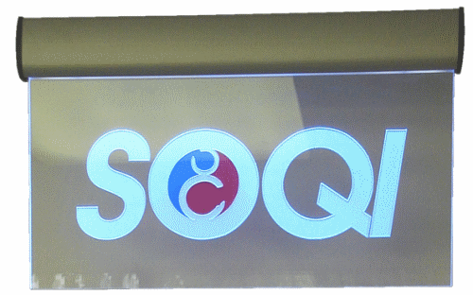 | Item Code: HTE-ASB001012  SOQI Sign  USD $ 240.00  BVP 0

