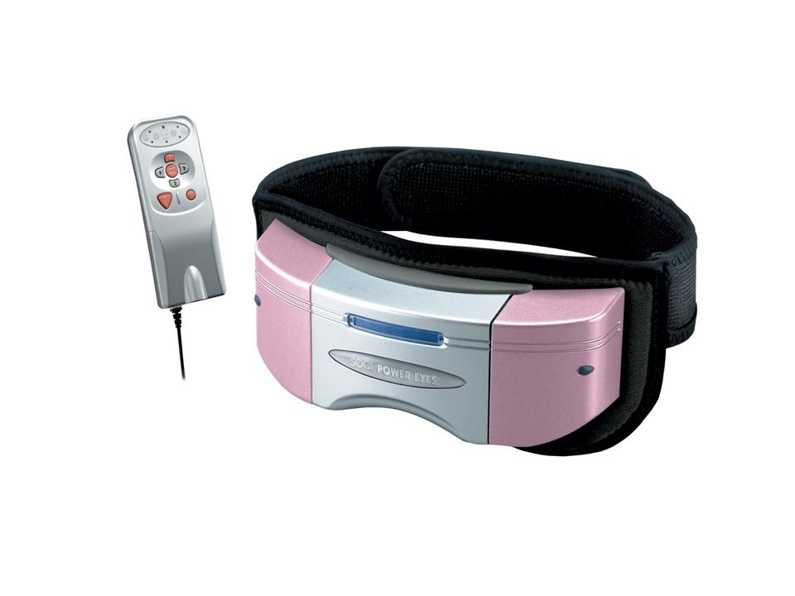  The Power Eyes combines air pressure, heat compress, and vibration massage which can improve blood circulation around the eye area. |  | Item Code: P0033M01  Power Eyes  USD $ 109.00  BVP 8

ALL of our products starting with { HTE- } may be purchased with your credit or debit card without the credit card surcharge on our over form.
No Out of Stock Fee with This Item
Order won’t go through if credit card owner and delivery address don’t match.

