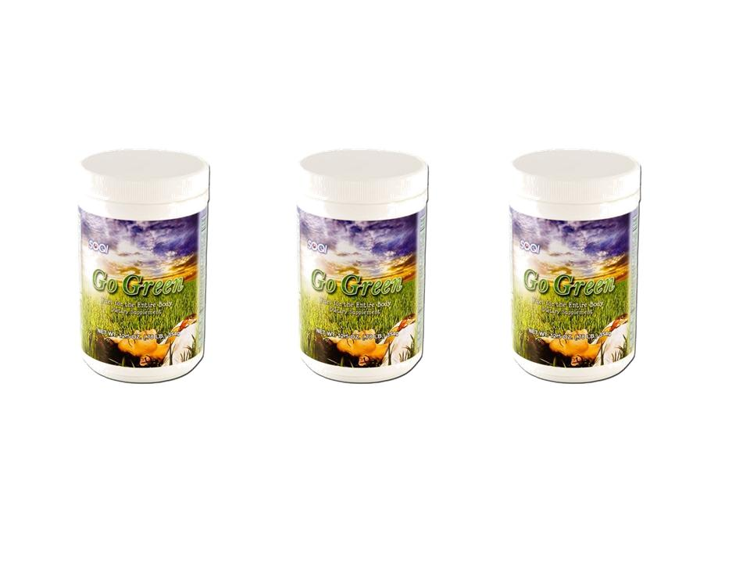  Go Green - Nutritional Supplement  Go Green is designed to energize, revitalize, alkalinize, cleanse, facilitate mental energy, support a healthy immune system and much more!  Go Green consists of a well balanced blend of 77+ quality ingredients for your daily diet. Balance your pH and balance your body with Go Green! | Item Code: HTE-P0007L03  Go Green Supplement 3 pack- (Enroll to Auto Ship and Get Free Shipping!)  Package Content  - GO-GREEN SUPPLEMENT x 3  USD $ 110.85  BVP 6

