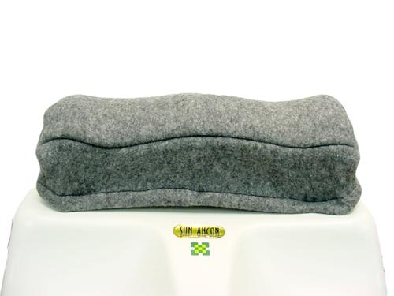 | Item Code: HTE-ASS001042  Footrest Cover for Chi Machine  USD $ 3.00  BVP 0
Keep your business equipment looking good with this replacement Chi foot rest Cover.
Keep your customers comfortable keep an extra one on hand in case something happens to the one your using.
This saves you shipping costs too.

