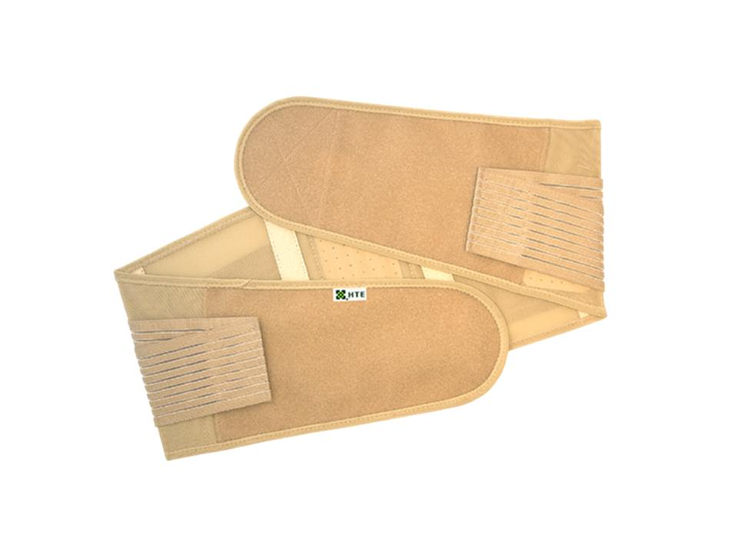 | Item Code: HTE-SF018S  Fir Waist Support (S) SMALL  USD $ 99.00  BVP 9
Item Code: HTE-SF018M
Fir Waist Support (M) MEDIUM
USD $ 99.00
BVP 9
-------------------------------------------------------
Item Code: HTE-SF018L
Fir Waist Support (L) LARGE
USD $ 99.00
BVP 9
----------------------------------------------------
Item Code: HTE-SF018XL
Fir Waist Support (XL) EXTRA LARGE
USD $ 99.00
BVP 9
-------------------------------------------------------

Item Code: HTE-SF018XXL
Fir Waist Support (XXL) EXTRA EXTRA LARGE
USD $ 99.00
BVP 9

