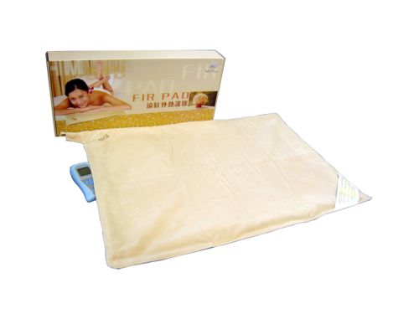 | Item Code: HTE-SY030A2  Fir Pad  USD $ 199.00  BVP 16

This is not medical advice & shouldn’t be taken as such. Joni Lund
This machine may or may not do so, not evaluated by the FDA for such.

