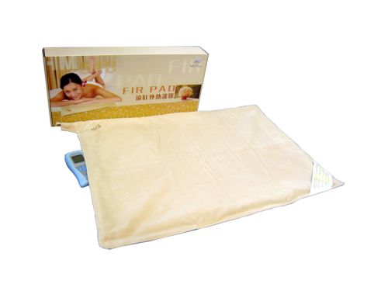 | Item Code: HTE-P0025M01  FIR PAD (Special Bundle)  ~Available only with your purchase of a single other machine~  USD $ 119.00  BVP 7  Special Bundle

This is not medical advice & shouldn’t be taken as such. Joni Lund
This machine may or may not do so, not evaluated by the FDA for such.

