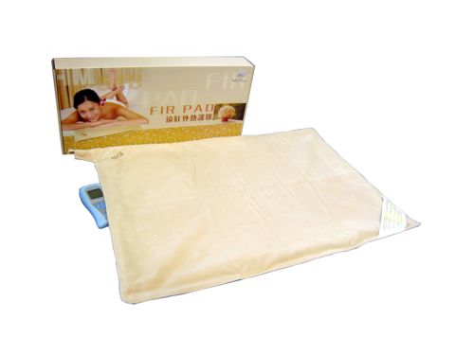 FIR Lumbar Cushion: Ergonomically designed lumbar support pillow; provides far infrared ray technology, penetrating heat and vibrating massage.  FIR Pad: A combination of thermal energy and Far Infrared Rays, the FIR Pad provides a wonderfully warmth and penetrating heath. | Item Code: HTE-P0031M01  FIR Pad + FIR Lumbar Cushion  Package Content  - FIR LUMBAR CUSHION x 1  - FIR PAD x 1  USD $ 249.00  BVP 18  8 Points
ALL of our products starting with { HTE- } may be purchased with your credit or debit card without the credit card surcharge on our over form.
No Out of Stock Fee with This Item
Order won’t go through if credit card owner and delivery address don’t match.
This is not medical advice & shouldn’t be taken as such. Joni Lund
This machine may or may not do so, not evaluated by the FDA for such.

