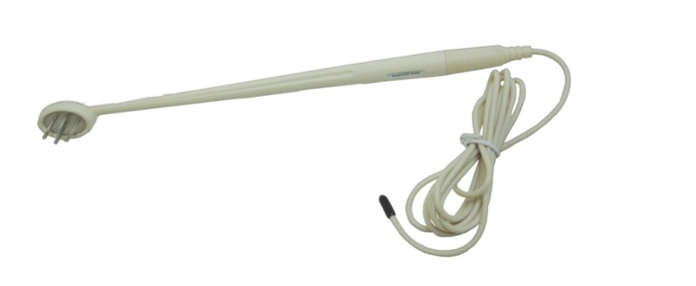  The design of the Energy Wand works in combination with the E-Power to help you unblock the energy pathways along the hands and feet. The idea behind it is to stimulate reflexology points and the body’s meridians. | Item Code: HTE-P0003M05  The Energy Wand  USD $ 59.95  BVP 5
ALL of our products starting with { HTE- } may be purchased with your credit or debit card without the credit card surcharge on our over form.
No Out of Stock Fee with This Item
Order won’t go through if credit card owner and delivery address don’t match.

This is not medical advice & shouldn’t be taken as such. Joni Lund
This machine may or may not do so, not evaluated by the FDA for such.

