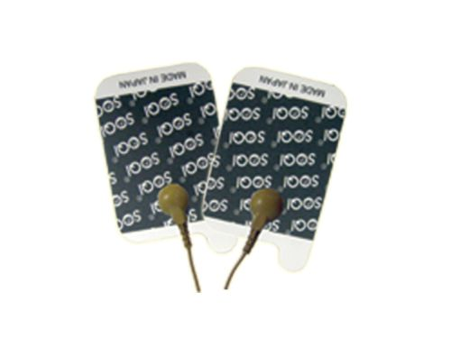 | Item Code: HTE-ASR002001  Electro Pads for Advanced Electro Reflex Energizer  USD $ 19.99  BVP 1

Replacement pads for your ERE. 2 per package.

