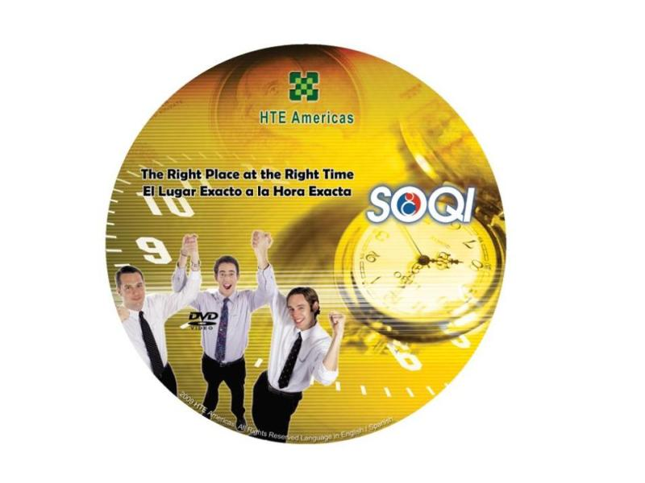 | Item Code: ABA001018  The Right Place At The Right Time DVD  USD $ 5.99  BVP 0

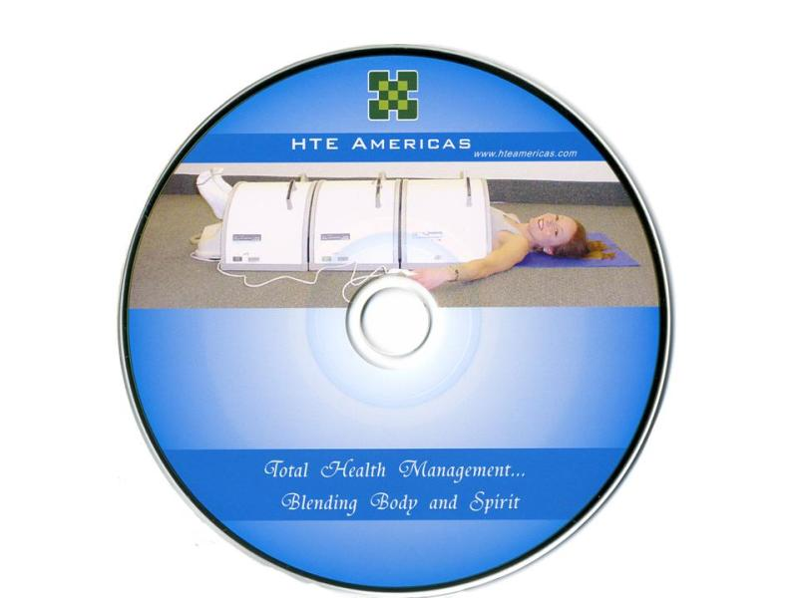 | Item Code: ASS001044  Blending Body and Spirit Music CD  USD $ 14.99  BVP 0

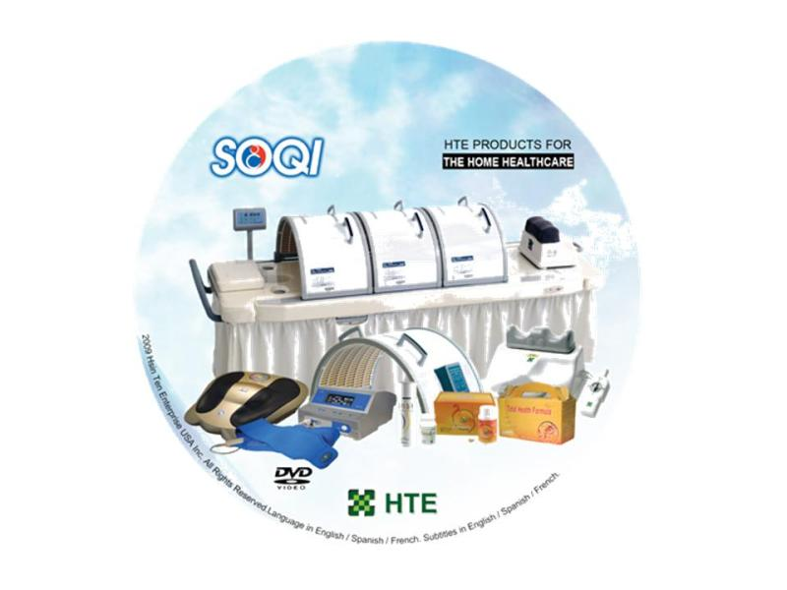 |  | Item Code: ABC001012  All Products DVD  USD $ 5.00  BVP 0
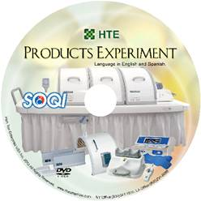 | Item Code: ABC001029  Products Experiment DVD  USD $ 5.00  BVP 0

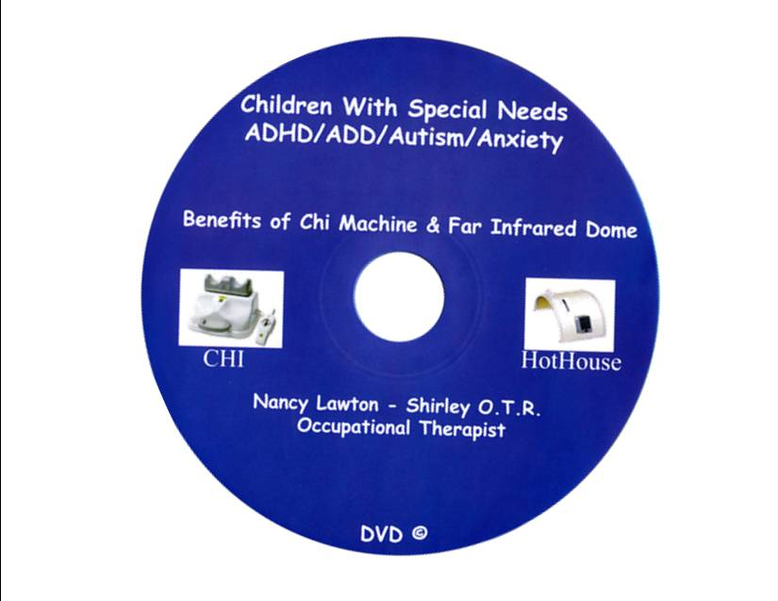 | Item Code: ABC001030  Children With Special Needs DVD  USD $ 5.00  BVP 0
Distributors and group home employees talk of their use and success with using Chi & Hot House Therapy in the MR and disabled group home settings.

Item Code: ANS007001
Total Health Formula/BetaLoe DVD
USD $ 5.00
BVP 0

Item Code: ASB001017
SOQI DVD
USD $ 5.00
BVP 0

Item Code: ASR002002
Advanced Electro Reflex Energizer DVD
USD $ 5.00
BVP 0

Item Code: AX0112
Products Experiment DVD / 50Pk
Package Content
- ALL PRODUCTS DEMO DVD x 50
USD $ 50.00
BVP 0
Item Code: AX0104
Total Health Formula/BetaLoe DVD - 50 Pack
Package Content
- TOTAL HEALTH FORMULA / BETALOE DVD x 50
USD $ 50.00
BVP 0

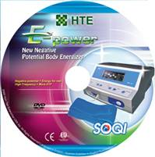 | Item Code: AX0105  E-Power DVD - 50 Pack e- E-Power DVD - 50 Pack  Package Content  - E-POWER DVD x 50  USD $ 50.00  BVP 0

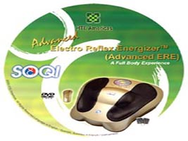 |  | Item Code: AX0106  Advanced Electro Reflex Energizer DVD - 50 Pack  Package Content  - ADVANCED ERE DVD x 50  USD $ 50.00  BVP 0
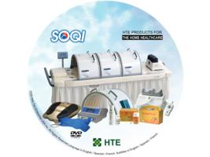 | Item Code: AX0107  All Products DVD - 50 Pack  Package Content  - ALL PRODUCTS DVD x 50  USD $ 50.00  BVP 0

Item Code: AX0108
SOQI DVD - 50 Pack
Package Content
- SOQI DVD x 50
USD $ 50.00
BVP 0

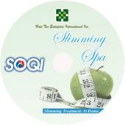 | Item Code: AX0109  SOQI Slimming Spa DVD - 50 Pack  Package Content  - SOQI SLIMMING SPA DVD x 50  USD $ 50.00  BVP 0

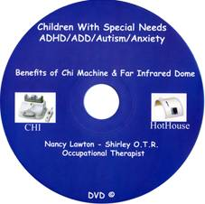 | Item Code: AX0124A  Children's With Special Need DVD / 50Pk  Package Content  - CHILDREN WITH SPECIAL NEEDS DVD x 50  Volume Discount Available!!  USD $ 50.00  BVP 0

