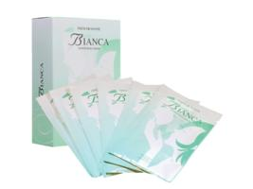 | Item Code: HTE-CX013A  Bianca Facial Mask *6 Pieces  Package Content  - FACIAL MASK (1 PIECE) x 6  USD $ 49.00  BVP 4

