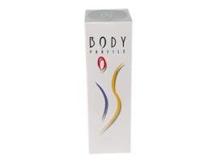 | Item Code: HTE-CB026  Bianca Body Profile  USD $ 69.99  BVP 6

