About Hypothyroidism
Type 1 Hypothyroidism
is defined as failure of the thyroid gland to produce sufficient amounts of thyroid hormones necessary to maintain "normal" blood levels of those hormones and "normal" blood levels of the thyroid stimulating hormone (TSH) produced by the pituitary gland. The TSH test is the standard blood test your doctor checks when looking for hypothyroidism. Around 7% of Americans suffer Type 1 hypothyroidism.
Type 2 Hypothyroidism
is defined as peripheral resistance to thyroid hormones at the cellular level. It is not due to a lack of adequate thyroid hormones. Normal amounts of thyroid hormones and thyroid stimulating hormone (TSH) are detected by the blood tests; therefore, blood tests do not detect Type 2 hypothyroidism. Type 2 hypothyroidism is usually inherited. However, environmental toxins may also cause or exacerbate the problem. The pervasiveness of Type 2 hypothyroidism has yet to be recognized by mainstream medicine but is already in epidemic proportions
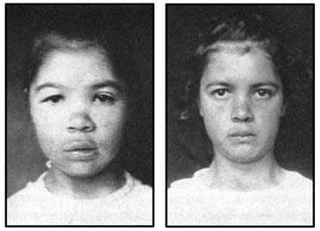
Above: A severely affected 14-year-old hypothyroid girl with puffiness around the eyes, thickened lips, depressed root of the nose (saddle nose), and straight, coarse hair. The second picture was taken after only 6 months of treatment with desiccated thyroid. Note the elevated bridge of the nose, brighter eyes, thinner lips, and glossy, curly hair. Her constipation had resolved and her appetite improved.
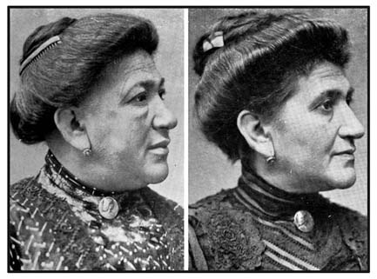
Adult woman with the characteristic puffiness that often accompanies hypothyroidism.
Her puffiness and hair texture markedly improve after treatment with desiccated thyroid.
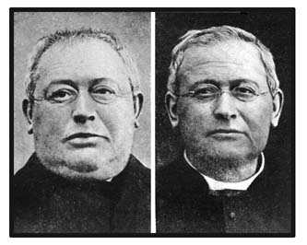
Adult man with the "obese form" of hypothyroidism. Note the striking resoltion of his puffiness (myxedema) after treatment with desiccated thyroid. Myxedema is the medical term for hypothyroidism. Myx is the Greek word for mucin, which accumulates in hypothyroidism. Edema means swelling.
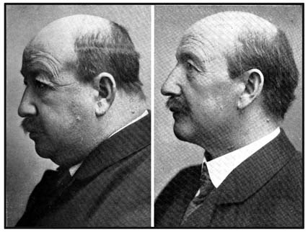
This is another example of the resolution of the puffiness (myxedema) following proper treatment of hypothyroidism with desiccated thyroid
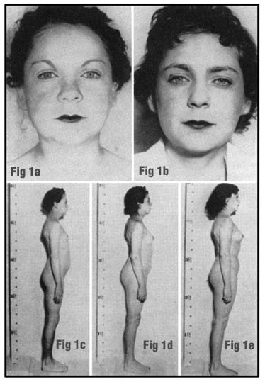
Figure 1a shows the appearance of a 27-year-old woman's face before treatment with desiccated thyroid. She had puffiness around her nose and eyes. Her menses gegan at age 16 and were irregular with scant flow. She had no interest in the opposite sex. There was an absence of pubic hair. She was constipated, gained weight easily, had dry skin and hair, had anemia, and she tired easily.
--------------------------------------------------------------------------------
Figure 1b shows the patient's face after 10 months of desiccated thyroid. She was about to be married. Her anemia was resolving. Her periods were every 26 days and the flow had improved.
--------------------------------------------------------------------------------
Figure 1c shows the side body profile of the same patient before treatment. The breasts had not developed and there was no hair on the arms and legs. Her height was 59 inches.
--------------------------------------------------------------------------------
Figure 1d shows the patient after 10 months of thyroid treatment. Her breasts had enlarged.
--------------------------------------------------------------------------------
Figure 1e shows the patient after 13 more months. A synthetic estrogen was added. Her breasts and pelvis enlarged further. Her libido and gratification increased.
Hypothyroidism and Global Warming Arguments
More Images of Myxedema (Hypothyroid)
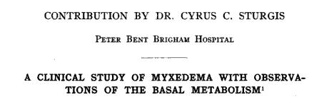
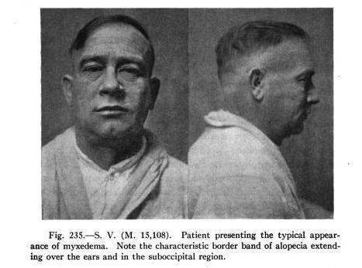
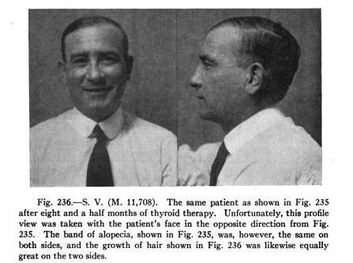
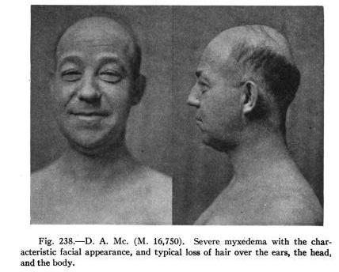
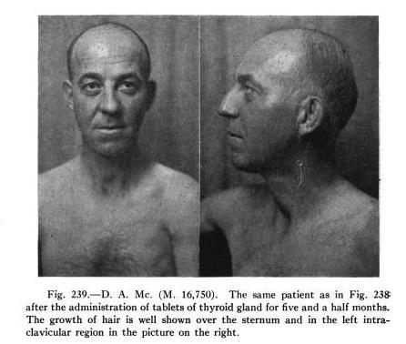
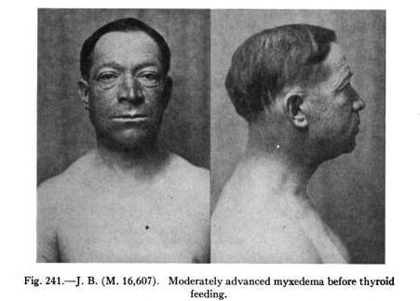
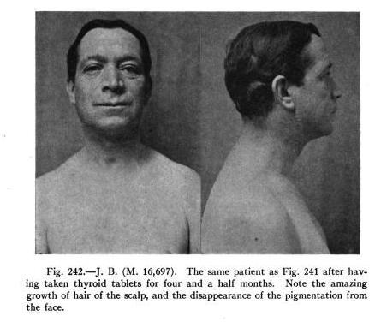
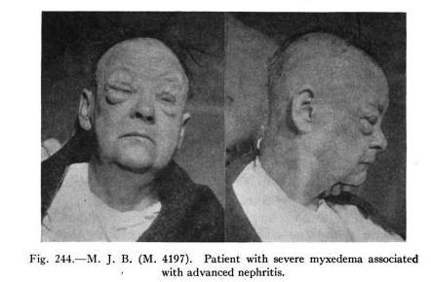
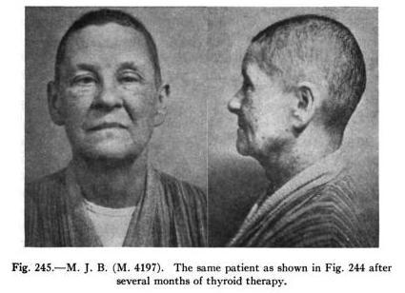
More on thyroid deficiency, myxedema, from the Medical Record Vol. 86, 1914
edited by George Frederick Shrady, Thomas Lathrop Stedman
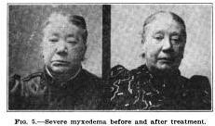XXXXXXX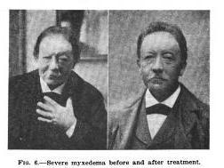
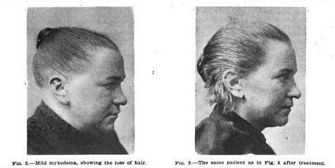
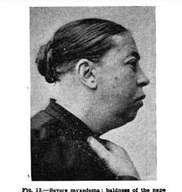XXX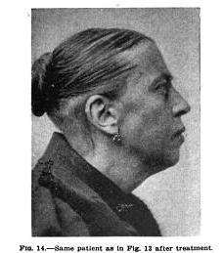
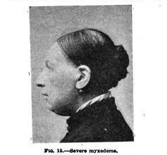XX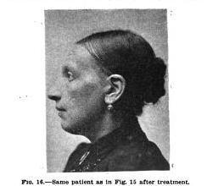
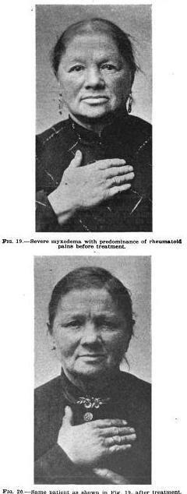
XXX
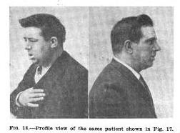XXX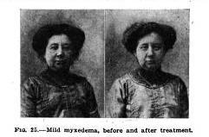
XXX
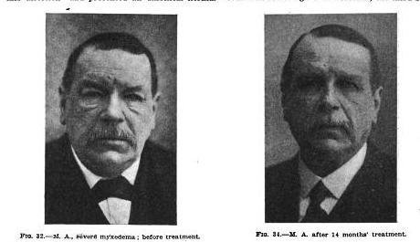
XXX
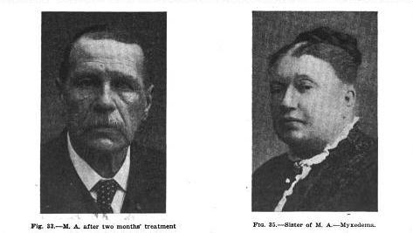
More on thyroid deficiency, myxedema, from the Medical Record Vol. 86, 1914
edited by George Frederick Shrady, Thomas Lathrop Stedman

"Makes children fat as pigs!"
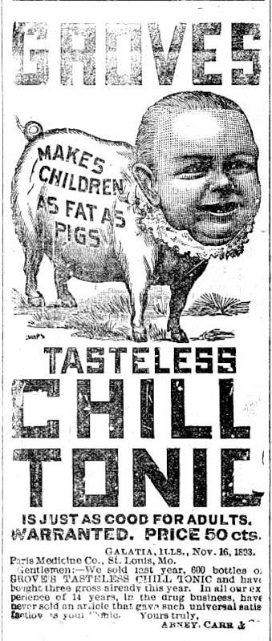
According to Dr. Jorge Fleschas, Dr. Grove's tonic (bromide based) was used to fatten up children.
Here is what Dr. Jarvis has to say about the Halogen's, one of which is Bromine, and their affect on displacing Iodine in the body: "There is a well-known law of halogen displacement. The halogen group is made up as follows:
Relative
Halogen Atomic Weight
Fluorine 19.
Chlorine 35.5
Bromine 80.
Iodine 127.
The critical activity of any one of these four halogens is in inverse proportion to its atomic weight. This means that any one of the four can displace the element with a higher atomic weight, but cannot displace an element with a lower atomic weight. For example, fluorine can displace chlorine, bromine and iodine because fluorine has a lower atomic weight than the other three. Similarly, chlorine can displace bromine and iodine because they both have a higher atomic weight. Likewise, bromine can displace iodine from the body because iodine has a higher atomic weight. But a reverse order is not possible. A knowledge of this well-known chemical law brings us to a consideration of the addition of chlorine to our drinking water as a purifying agent. We secure a drinking water that is harmful to the body not because of its harmful germ content but because the chlorine content now causes the body to lose the much-needed iodine."

