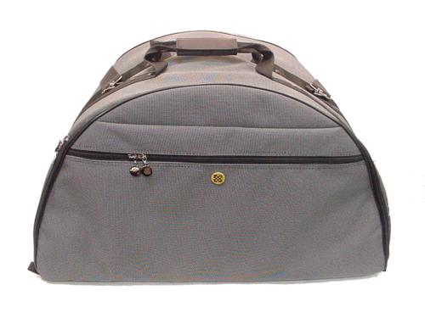 | Item Code: HTE-ASY010001  Hot House Carrying Bag - Regular size  USD $ 59.99  BVP 2

This bag make it easier to protect your investment while providing a easier way to transport your Hot House(s).

