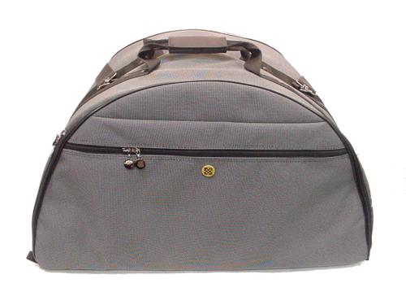 | Item Code: ASY010002  Grande Hot House Carrying Bag - GRANDE  USD $ 69.99  BVP 2

Protect you Grande Hot House with this easy to carry bag.

